Introduction

With all of the translations readily available in America today, it is hard to imagine a world without any of the scripture in English, but such was the case less than 700 years ago. In this lesson we will seek to give a brief historical knowledge at early English translations prior to the King James Version and then show the development of the major modern translations now available. Hopefully after this lesson, the average Christian will have a better appreciation at the miracle that they hold in their hands every time they seek to read a verse, because there have been many who have died in order for us to have such a privilege!

The Early Years

The first translation of any of the scriptures was undertaken by John Wycliffe in the years of 1381 to 1384. It was a handwritten translation into English not from the original languages but from the Latin Vulgate, the official Catholic Bible of the time. By this time, the Roman Catholic Church’s stance was that the scriptures should only be read by priests and official clergy of the church and so therefore the Bible should only be in Latin which was no longer spoken by the common man. The Catholic Church believed – and still somewhat does – that the average believer could not understand the Bible for themselves. John Wycliffe believed “the laws of the Bible were more important than the laws of the church” an opinion not endearing to the Catholic Church of his day. When Wycliffe put copies of the English Bible in the hands of ordinary people and encouraged them to preach the Gospel, the Catholic church condemned him to die and he was tried first in 1378 and then again in 1382. He was pronounced a heretic but was able to retreat and live in seclusion until his death. While in seclusion, he wrote prolifically against the hypocrisy and unscriptural stances of the Roman Catholic Church. In 1414, the church denounced all of these writings and had his bones dug up, burned, and thrown into the River Swift. The stage was set and the lines were drawn: if an English translation was going to be made widely available for the people, it would be in direct opposition to the Roman Catholic Church.

Two very important historical events led the way for the first true English translation. First, the printing press was invented leading to the possibility of duplicating large books much quicker and accurately than handwritten copies. Second, the large city of Constantinople was attacked by the Turks and many influential Christians fled the town traveling to Italy and bringing ancient copies of the Greek New Testament and of the Septuagint with them. A man named Erasmus, a catholic clergyman, began to compile these Greek manuscripts into the first “text type” and for the first time an edited Greek New Testament was published and became widely available in the years of 1516-1517. Erasmus began to discuss the possibility of an English translation of the Bible from the original languages. His Greek text would become the general basis for the Textus Receptus of today. Erasmus’ Greek New Testament showed to the scholars of the day just how corrupt and faulty the Catholic Bible, the Latin Vulgate, had become. As this realization began to set in among those educated enough to read Koine Greek, the need was for someone with the boldness and education to bring about an accurate English translation.

William Tyndale

William Tyndale is the hero of the history of the English Bible. He was an Englishman educated at Oxford and spent his younger years mastering Greek, Latin, and Hebrew. In 1517, Martin Luther nailed his famous ninety-five theses to the door of his church in Germany outlining 95 areas that he believed the Catholic church had erred from scripture. After his split from the Catholic Church, Luther translated the New Testament into the average, day-to-day German dialect used by the average churchgoer of his time. Having also realized how far the Catholic church had gotten away from the original scriptures, William Tyndale began to dream of also translating the Bible from the original languages into a common everyday English spoken by the masses. He began to approach friends in the local churches about supporting and funding such an endeavor and was usually rebuffed and condemned. This opposition only caused the passion to translate to burn brighter in Tyndale. In one famous argument with a critic, the opponent said “we were better be without God’s Law than the Pope’s.” To which Tyndale replied, “I defy the Pope and all his laws. If God spare my life, before many years I will make sure that a boy who drives the plough knows more of the Scriptures than you do.”

When he approached the Bishop of London for support, the bishop refused and Tyndale had to flee England to go to Germany. When the opposition arose in the town of Cologne, he fled to the city of Worms where he translated the New Testament into English. These copies were smuggled into England in bales of cloth and when some were found, the Bishop Tunstall held a service where these copies of the Bible were burned as a sign of their “heresy.” Tyndale fled to the town of Antwerp where he translated fourteen books of the Old Testament into English. In 1534, he produced a carefully revised and much improved edition of the New Testament. Despite the fierce opposition, people adored being able to read the Bible for themselves in a language that they could understand. And Tyndale’s translation skills were incredible: producing a “free and bold” language that captured the minds and hearts of the reader.

In 1535, a friend betrayed Tyndale and he was captured and imprisoned for eighteen months. On October 6, 1536, he was – according to Foxe’s Book of Martyrs: “brought forth to the place of execution, was there tied to the stake, and then strangled first by the hangman, and afterwards with fire consumed, crying thus at the stake with a fervent zeal and a loud voice, ‘Lord, open the King of England’s eyes’.” His crimes were all religious charges trumped up by the Catholic Church of England; his only real crime was in making the Bible available to the common Englishman.

The impact of Tyndale’s translation style on the English-speaking world and future translations is incalculable. You quote him often and do not realize it. It was Tyndale who penned such phrases as:

Let there be light
Eat, drink, and be merry
The powers that be
A prophet has no honor in his own country
Ye of little faith
Fight the good fight
Am I my brother’s keeper?
The spirit is willing . . .
The salt of the earth
A law unto themselves
A man after his own heart
Signs of the times

The English-speaking world is forever indebted to the work of this remarkable man. His was the first English translation taken directly from the Greek and Hebrew. In fact, his partial Old Testament was the first Hebrew anything to be translated into English. How sad that the very work for which he gave his life, is often the most unread book in the modern house!

The Dawn of Official Translations

What Tyndale would never know was that God had already begun to answer his prayer. The King of England, Henry the VIII had broken all ties with the pope because of their denunciation of his marriage to Anne Boleyn. Anne, leaned toward a Protestant faith and favored an English translation of the scriptures. A friend and fellow editor of Tyndale, named Myles Coverdale, translated the remainder of the Old Testament relying heavily on Tyndale’s study notes, revised some of the other parts of the scripture and published the Coverdale Bible in 1535 in Europe. It was the first time the entire Bible had been printed in English. Coverdale is most famous for his work on the 23rd Psalm and it is he who gave us the phrases “the valley of the shadow of death” and “anointest my head with oil.” Anne Boleyn was beheaded not long after the publishing of Coverdale’s Bible and with her demise so died the popularity of this early translation.

Meanwhile, King Henry VIII sanctioned another translation, to be an “official England” English translation. Another friend and colleague of Tyndale, John Rogers produced the new translation. No idiot, and realizing how quickly royal will could change, Rogers produced the Bible under the pen name Thomas Matthew, and it became known as Matthew’s Bible. It contained more of Tyndale’s original work than even the Coverdale Bible did and it also contained a page between the Old and New Testaments with an artistic W.T. engraved as a tribute to Tyndale. The Matthew’s Bible was essentially a revision of Coverdale Bible to include more of Tyndale’s work.

In 1539, a revision of Matthew’s Bible was published by Richard Taverner and became known as Taverner’s Bible. It is noteworthy only because he changed Tyndale’s “similitude” to the familiar “parable.” Coverdale’s Bible, Matthew’s Bible, and Taverner’s Bible were all published with extensive commentary on the scripture and in 1538, King Henry VIII decreed that a Bible “of the greatest volume” be produced without any notes and only containing scriptural text, and that a copy be set up in every local parish church. The result was The Great Bible and it became so popular that church services were often cancelled because every night and spare minute, crowds of people would flock to the local churches just to take turns reading aloud the scripture for themselves! Coverdale compiled The Great Bible which was a combination of Coverdale’s, Matthew’s, and Taverner’s Bibles.

The remaining translations are a product of whomever happened to be in control of England at that particular time. Here is a quick overview of English monarchs from Tyndale to the time of the KJV with their religious leanings:

Monarch Reign Religious Leaning Major historical significance

Henry VIII 1509-1547 Catholic at first Broke with Rome in 1534
Edward VI 1547-1553 Fervent Protestant --
Mary I 1553-1558 Fervent Catholic Known as “Bloody Mary”
Elizabeth I 1558-1603 Fervent Protestant --
James I 1603-1625 Protestant Also known as “King James VI of Scotland”

King Edward VI simply maintained the status quo and The Great Bible continued to be used extensively throughout England. When Mary I became queen, she killed so many protestants that she became known as “Bloody Mary.” The first that she killed by burning at the stake was John Rogers, the producer of the Matthew’s Bible. During her short reign, protestants fled England by the droves. Many of them moved to Geneva, Switzerland and in 1557, the New Testament of what would become known as the Geneva Bible was published and both the Old and New Testaments were published in 1560. The Geneva Bible was the first to have numbered verses, making cross references possible and particular passages easier to find. It also was the first to be set in Roman type seen today and not printed in the harder-to-read Gothic or black-letter print. Another feature was to print in italics words that were not in the original Hebrew and Greek but were supplied by the translator for better readability. This was a feature continued in the KJV and in many modern translations today.

The Geneva Bible became the most popular translation of the early years and continued to be the favored translation of many Protestants and Puritans even many years after the publishing of the King James Version. The Geneva Bible was the one used by William Shakespeare and was the translation taken first to America by the Pilgrim Fathers aboard the Mayflower when they set sail in 1620.

In 1568, a relatively poor quality translation that leaned heavily on the Latin was published entitled the Bishop’s Bible. It was supposed to be a Catholic answer to the Geneva Bible. In 1610, Catholic scholars performed another English translation from the Latin Vulgate and it became known as the Douai-Rheims Bible. These were the Catholic answers to the Great Bible and the Geneva Bible but both suffered from their reliance on the corrupt Latin. It would not be until 1966, that Catholic translators would produce a translation from the original Greek and Hebrew and that translation would become known as the Jerusalem Bible.

The King James Version

In 1603, King James VI of Scotland became King James I of England and at the time the number of English translations was a source of religious disunity in the country. Three groups: Catholics, Protestants, and Puritans were now clamoring for a new translation one that was “unbiased” as to one doctrinal side. In 1604, King James agreed to their proposal and declared that the Bishop’s Bible be revised with consultation of Tyndale, Matthew, Coverdale, and the Great Bible. The only side notes to be allowed were to be when an explanation of the original Greek or Hebrew was necessary. About fifty scholars were divided into six panels, with two working on the New Testament, three on the Old Testament and one on the Apocrypha. When a panel finished their work, it was sent to all the rest for comment and critique. Then representatives from all six panels met and made final translation decisions. This style of “committee translations” served to keep personal religious bias from dominating the translation and became an important precedent for future Biblical translations.

The translation was originally known in Britain (and still is today known in Britain) as the Authorized Version. The title “the King James Version” is only used in America. The translation was completed in three years – a remarkable achievement. The KJV is not technically a new translation as is commonly believed today but rather a revision of the earlier efforts with an eye toward the original languages. In a lengthy preface which is usually not included in modern printings today, the translators of the KJV wrote that their aim was not to make “a new translation, not yet to make of a bad one a good one . . . but to make a good one better, or out of many good ones one principal good one.” This goal, they largely accomplished.

There are many other false assumptions about the AV/KJV that are misunderstood today and several random historical points can clear up much here. First, because it followed largely the wording of earlier translations, the English of the KJV was dated when it was first printed. When it was produced, the Elizabethan tendencies towards “eth” endings and “thous” and “thees” were largely fading from common use. Another point to note is that the KJV has been largely praised for its magnificent English renderings of the Greek and Hebrew text, and in many places the eloquence of the passage is indeed great. But most of this eloquence is from the influence of Tyndale’s work on the translators of the KJV. Recent studies have discovered that a full 84% of the KJV New Testament is actually where the translators reverted back to Tyndale’s work, and 75% of the Old Testament books that Tyndale translated found their way into the KJV text. In fact, the Old Testament books that were not influenced by Tyndale’s earlier translations are the worst rendered English of the KJV. Something else that many modern believers do not realize is that it took several decades before the KJV replaced the Geneva Bible and Bishop’s Bible as the common man’s everyday Bible in England. Much of the same criticisms launched by some people against modern English translations were hurled at the KJV when it was first produced.

A final assumption by many modern believers is that King James was a model Christian who approved of everything about the version bearing his name. The facts are that King James, while having protestant leanings, was quite rude and had little sympathy towards any form of Puritans or what he deemed as “too Presbyterian.” But he consented to the translation of a new Bible because of his dislike of the Geneva and Bishop’s Bibles. Many later editions of the KJV were published with a dedication page building him up to be some great spiritual guru with great words like:

“To the most High and mighty Prince, James, by the grace of God, King of Great Britain, France, and Ireland, defender of the Faith,” etc . . .

As a man, the king nowhere lived up to such acclaim and was “head of the Church of England” simply because of his title of king, not because of virtue of life. The simple truth is that King James was raised in a very tragic manner with relatives often being murdered and deceitful. He was raised with very little contact with women and history documents that in his early teenage years, an older French cousin, a man named Esme Stuart D’Aubigny became his homosexual partner. All of his life, King James lived in open immorality, a brazen homosexual and a drunk.

The King James Version of the Bible is a wonderful English translation and served the English world well for many years, but that is because of the lack of influence of King James and not because of him. The scholars’ style of working in teams with each other helping to critique each other’s work led to a translation not largely biased as to on particular belief. That, combined with their heavily leaning on Tyndale’s marvelous talent, is what led to the beauty of the KJV, not because of the king that gave permission for it to be translated during his reign. I have heard some people voice the opinion that because the KJV was called “the authorized version” that it was somehow a better translation than others because of King James’ name being attached to it. As an appeal to common history reveals, nothing is further than the truth. He simply okayed the translation process to take place. The applause for such a good translation goes to the translators and a long forgotten man named William Tyndale.

Into the Modern Era

The King James Version became the primary English Bible for almost four centuries of believers. It is the best-selling English book of all time and it would not be until 1986 that another English translation would outsell it. Many people wrongly assume that the KJV of today is the original 1611 edition but that is not the case. Here is a list of subsequent revisions of the KJV:

1612 - minor improvements, mainly printing errors.
1613 - major revision with 413 wording changes.
1616 - changed 1 Corinthians 4:9 from "approved to death" to "appointed to death."
1629 - some editions dropped the Apocrypha from the text.
1629 - minor improvements published as the "Cambridge edition."
1638 - major revisions by Goad, Ward, Boyse and Mead. Some of these revisions were
later changed back.
1659 - William Kilburne claimed to have identified 20,000 errors that had crept into six
different editions that were printed in the 1650s.
1762 - extended the use of italics for words added by translators; modernized the
language.
1769 - extensive revision by Benjamin Blayney. Spellings and punctuation were
modernized.

An example of some of the spelling changes of the 1769 revision are that "Hieruslaem," "Marie," "assone," "foorth," "shalbe," "fet," "creeple," "fift," "sixt," "ioy," "middes," "charet," and similar instances were changed to the familiar terms of the edition that we have today. One can still buy a reproduction of a 1611 KJV today but it is largely unreadable to today’s English.

The first serious revision of the King James Version was undertaken by the Church of England in 1885 and was called the Revised Version. Although used by some scholars, the RV was not well received because as scholar F.F. Bruce said, “it was strong in Greek, weak in English.” In general, the Old Testament of the RV was better and clearer and more accurate than the KJV and the New Testament was worse than the KJV. An American revision of the RV was published in 1901 as the American Standard Version and it did much better here than overseas. One transformation of the ASV over the RV and the KJV was the standardized use of Holy Spirit instead of Holy Ghost. Both the RV and the ASV failed to modernize the English to fit common usage, and this was primarily their reason for lack of popularity. The KJV was still the most used English translation worldwide.

Throughout the years, many more manuscripts of the original languages had been discovered, and in the mid 1900s, the need was seen for another English translation that not only better reflected the English spoken today but also reflected the many, older copies of the original languages that were now possessed by scholars. In 1952, the Revised Standard Version was produced, a further revision of the RV/KJV family. Most but not all archaic language such as “thous” and “thees” were removed except when divinity was being addressed. One curious choice was to address Jesus as “you” until after His ascension and then render it “thou.” Another poor translation choice was the changing of Isaiah 7:14 to read to “ “a young woman shall conceive” rather than “a virgin shall conceive.” The RSV sold well until the early seventies, but because of such curious translation choices did not seriously dent the popularity of the KJV with most conservative Christians.

The only other new English translations of note before 1970 were the Amplified Bible which tried to insert every possible meaning of a Greek word into the text but reads somewhat like a Thesaurus, and the Living Bible – not a translation at all but a paraphrase of the ASV – that a minister named Kenneth Taylor wrote to read to his children. While easily read, the Living Bible should not be used for serious Bible Study as it tends to be very much Taylor’s own opinion or interpretation of the Bible. It is no longer in print. Another paraphrase known as J.B. Phillip’s New Testament was much more accurate – as far as a paraphrase can be accurate – and is still available today. Again, no paraphrase should be used for serious scriptural study or doctrine. At this time British scholars were working on the New English Bible, and the Catholics were working on the Jerusalem Bible and the New American Bible, but in this study we will focus only on American English translations.

In 1971, a conservative revision of the ASV organized by the Lockman Foundation was published entitled the New American Standard Bible. The NASB was of a much more literal translation philosophy and was even more literal than the KJV! It tended to overall make better translation choices than the RSV and yet had some curious translation choices such as the retaining of “Thee” and “thou” language only in prayers prayed to God. The NASB’s biggest downfall, however, was the stiff woodenness of the English renderings but despite it tough reading text, it was the best-selling modern Bible in America by 1977. In 1995, the NASB was revised to make it more readable and the translators largely succeeded in their goal. The NASB has now been replaced by the NASBU (New American Standard Bible Update) which reads better but is still the most literal English translation in print. The NASBU removes all archaic language and makes some minor revisions and is the standard Bible of most seminaries and the academia world. We will discuss the NASBU’s strengths and weaknesses in a later lesson in this series.

In 1976, the first meaning driven translation was produced entitled Today’s English Version or the Good News Bible. It is on the far end of idiomatic philosophy and was essentially a paraphrase in many places. It was better received in Britain than in the United States.

In 1978, the New International Version was produced and by 1986, the NIV became the best-selling English Bible and the first to surpass the KJV in yearly sales. The NIV was translated by a team of scholars from all over the world – hence the name “international” – and tried to “walk the fence” between a more literal approach to translation and a phrase by phrase, idiomatic approach. We will discuss the strengths and weaknesses of the NIV in a later lesson in this series.
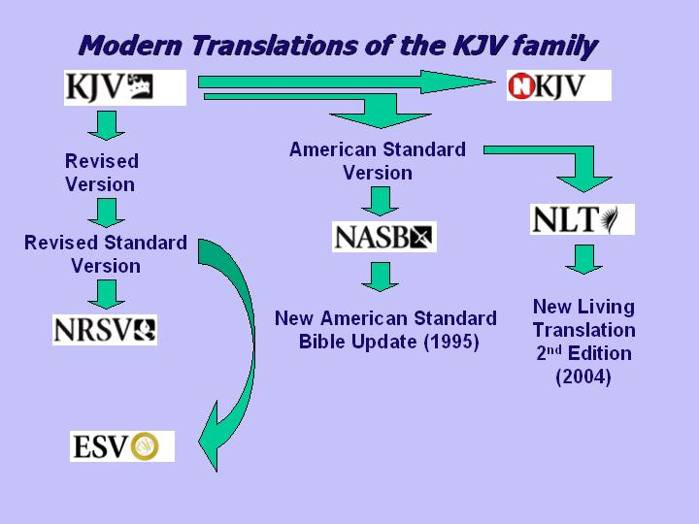
In 1982, the New King James Version was produced by the Thomas Nelson Inc. It was at first intended to be a revision of the KJV with just the removal of the “thees” and “thous” but when they discovered that the text was too close to the original KJV as to be un-copyrightable, more extensive revision was made. The New King James Version in most places limits itself to the manuscripts available to the KJV translators in the 1600s but in some places makes some surprising changes. It has sold well in the U.S. largely because of believers swayed by the “King James” in the title. The New King James Version is primarily to a target audience of those used to the KJV but needing a more modern English translation to preach or teach from. We will discuss the strengths and weaknesses of the NKJV in a latter lesson.

In 1986, the International Children’s Bible, the only full Bible patterned for children was produced. It was a revision of a simplified language version of a Bible for the deaf. In 1991 an adult revision of the ICB was released in the form of the New Century Version. It is the only English adult translation that began as a child’s edition rather than vice versa.

In 1990, the New Revised Standard Version was produced as a further revision of the RSV. The NRSV tends to keep the poor translation choices of the RSV and has also aggressively changed to inclusive language (ie…using “people” or “humanity” for “mankind”). In fact, the NRSV has been so aggressively changed to inclusive language that many critics think that they have included passages when it was not warranted. Nevertheless, it has sold fairly well with the academia world and among some evangelicals.

In 1995 the Contemporary English Version was published by the American Bible Society. The CEV is a very idiomatic translation that was intended for reading aloud to a group and for people for whom English is a second language. I personally read the entire CEV through a few years back for my personal devotion time and my impressions were that the Old Testament was wonderfully clear and accurate, and the New Testament tended to make some very poor translation choices in some key doctrinal texts.

In 1996, another idiomatic translation was published under the title New Living Translation. Produced by the publishers of the Living Bible paraphrase, it is in my opinion an unfortunate decision to have kept the same name because unlike the Living Bible, the NLT is an actual translation by a team of scholars and thought to be by many the best of the idiomatic English translations. It was revised again in 2004 and this second edition, the NLTse, continues to sell well in America.

From 1993 to 2002 the paraphrase, The Message, was released by a minister named Eugene Peterson. Both my wife and I have read it and it is phrased in modern, colloquial, American English. Again I will remind you that no paraphrase should be used for serious Bible study or doctrinal decisions.

In 1997, the NIV announced a revision of the NIV using inclusive language. It was largely criticized and heavily opposed in America so the NIVi is not readily available. In 2005, a slightly more idiomatic NIV revision of the New Testament called Today’s New International Version was released. The TNIV also uses inclusive language. The translation of the TNIV Old Testament has not yet been finished. The NT contains about 7% difference in text from the NIV.

In 2001, conservative translators upset by the plans for the gender inclusive language of the TNIV and NRSV, met together to produce another English translation in the KJV/ASV family. The result was the English Standard Version, a work much more literal than the NIV and with much more conservative translation decisions than the NRSV. Published by Crossway Books, the ESV has done relatively well in recent years’ sales. We will discuss the strengths and weaknesses of the ESV in a future lesson.

In 2004, the Southern Baptist Convention released the Holman Christian Standard Bible. The HCSB was intended to be a replacement for the NIV in Southern Baptist churches due to their concern of the gender inclusive changes advertised as coming to the NIV. The HCSB has sold well due to its support by the Southern Baptists and is slightly more literal than the NIV. Its English reads a bit more wooden than the NIV. We will discuss the strengths and weaknesses of the HCSB in a future lesson.

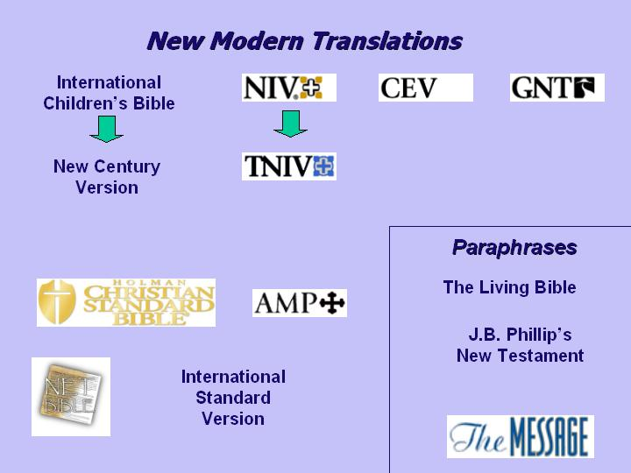
This brings us to a current standing in the major English translations. A future idiomatic translation, the International Standard Version released their New Testament in 1999 but the Old Testament is only about a third complete. The ISV NT was not greeted well by scholars and critics upon its release. Another version is found entirely on the internet and is called the NET Bible (New English Translation). It is a fairly literal and fairly accurate translation but not able to be used as a primary Bible because it is constantly being revised. A revision of the CEV is being planned and the release of the Old Testaments of the TNIV and the ISV are still to come.

According to the Christian Booksellers Association, the ten best selling Bible translations in America for April 2006 were:

- New International Version (NIV)
- New King James Version (NKJV)
- King James Version (KJV – 1769 revision)
- New Living Translation (NLTse)
- Holman Christian Standard Bible (HCSB)
- Reina – Valera 1960 (Spanish Bible)
- The Message
- New American Standard Bible Update (NASBU)
- English Standard Version (ESV)
- New International reader’s Version (NirV – a children’s version of the NIV)

This excellent chart is drawn from Dewey, David; A User’s Guide to Bible Translations. (pg 119)
That English translation which is still the current number one seller is the New International Version (NIV).
In the Greek, both phrases are from the same word, pneuma.
Go to www.bible.org/netbible . It is also available as audio Mp3 files.

